# Installing Your Qiosk

Your Qiosk will come pre-installed on the hardware from our office so it's ALMOST ready to use straight away. The only thing you will need to do is configure your internet connection.

Turn the kiosk on and let it start up. It will likely show a “Network Error” because it doesn’t have an internet connection.

Tap each corner of the screen in a clockwise direction - top left, top right, bottom right, bottom left.



You will be asked for a code to unlock the kiosk. Press Keyboard button to enter your unlock code. The Kiosk **Unlock Code** is 3621.

You will be presented with a Windows Lock screen like below, from which you can switch user, as per further instructions below.

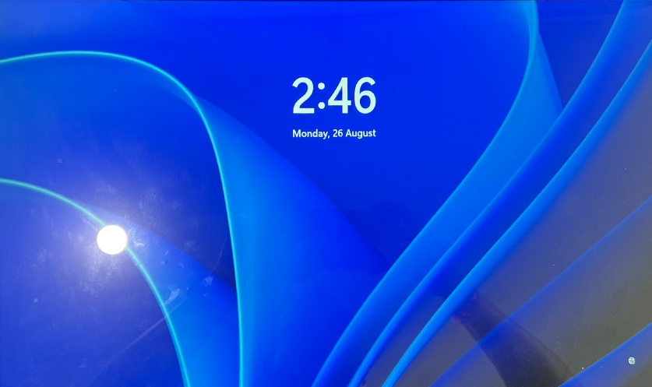

Tap on it (swipe from bottom to top), so you see the Windows User Selection screen, select **Kiosk (Kiosk Admin User)** user and enter your password (please see attached note for Password for your Kiosk Admin User). Please also destroy the password note once you store that password somewhere securely.

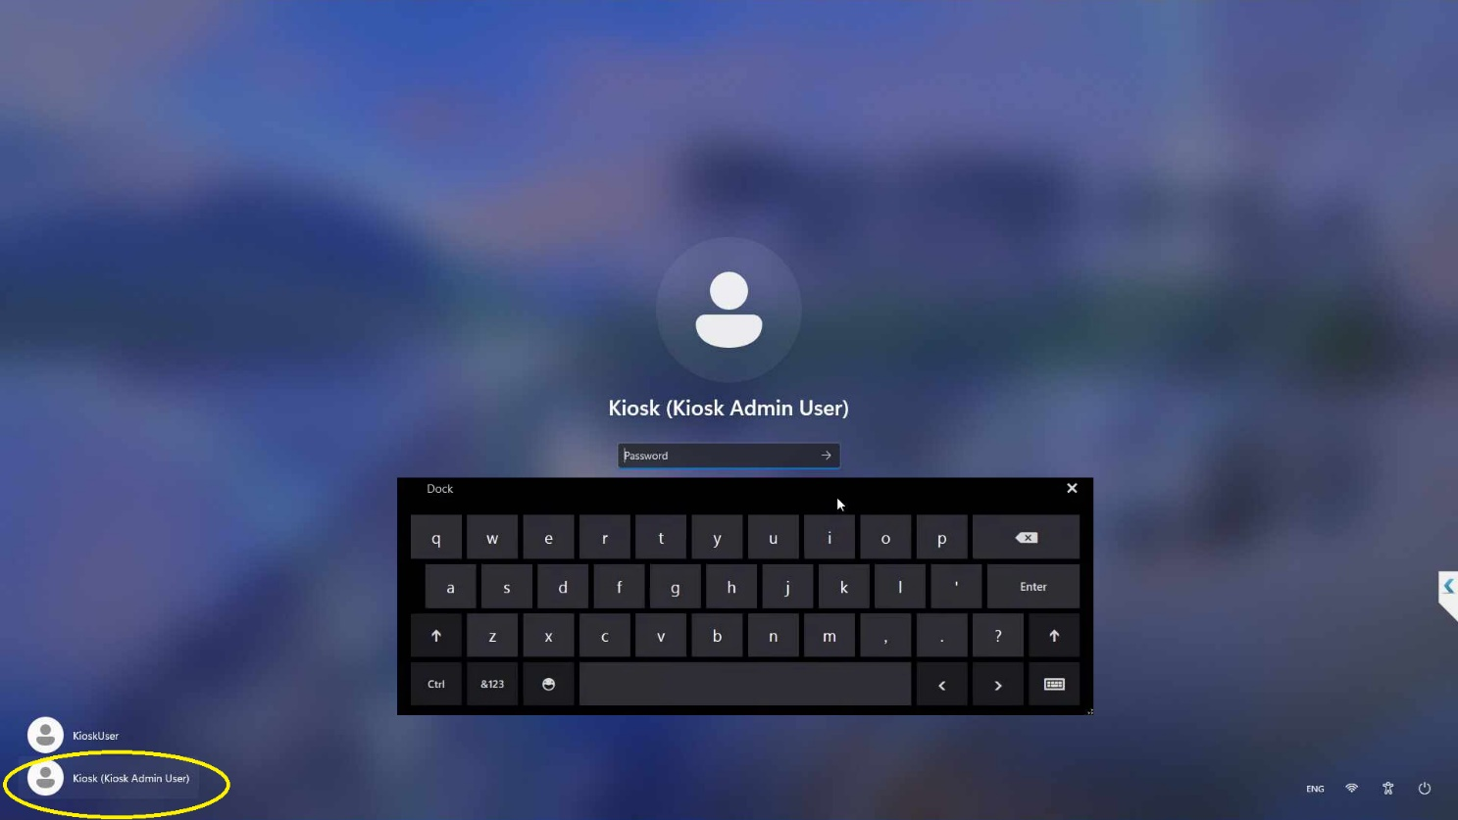

Once you are logged in, click the internet icon in the toolbar at the bottom of the screen. Then turn on the wifi and select the network you want to join. Please make sure to choose “Connect Automatically” for WIFI network which the Kiosk can connect to successfully.

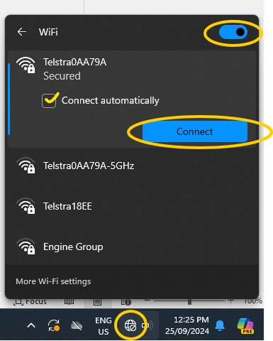

**Steps to Follow Once Connected to Internet (Restart Kiosk)**

Once you have connected to WIFI successfully, switch off the machine and switch it back on again and the Qiosk will automatically start up!

**Mobile Hotspot Connection**

In case Kiosk can’t connect over to a known WIFI Connection, the personal hotspot of your mobile or tablet can be turned on. Please use this option only in case the shared WIFI Connection is not available. The instructions for setting up personal hotspot are included below.

**How to set up a Personal Hotspot on your iPhone or iPad**

A Personal Hotspot lets you share the mobile data connection of your iPhone or iPad (Wi-Fi + Cellular) when you don’t have access to a Wi-Fi network.

**Set up Personal Hotspot**

1. Go to Settings > Mobile Data > Personal Hotspot or Settings > Personal Hotspot.
2. Tap the slider next to Allow Others to Join.

If you don’t see the option for Personal Hotspot, contact your service provider to make sure that you can use Personal Hotspot with your plan.

**Connect to Personal Hotspot with Wi-Fi, Bluetooth or USB**

You can connect to a Personal Hotspot using Wi-Fi, Bluetooth or USB.  And with iOS 13 or later, devices that are connected to a Personal Hotspot will stay connected, even if the screen is locked, so those devices will still receive notifications and messages.

When you connect a device to your Personal Hotspot, the status bar turns blue and shows how many devices have joined.  The number of devices that can join your Personal Hotspot at one time depends on your service provider and iPhone model. If other devices have joined your Personal Hotspot using Wi-Fi, you can only use mobile data to connect to the internet from the host device.

Use these steps to connect:

**Wi-Fi**

On the device you want to connect to, go to Settings > Mobile Data > Personal Hotspot or Settings > Personal Hotspot and make sure it’s turned on. Then verify the Wi-Fi password and name of the phone. Stay on this screen until you’ve connected your other device to the Wi-Fi network.

On the device you want to connect, go to Settings > Wi-Fi and look for your iPhone or iPad in the list. Then tap the Wi-Fi network to join. If asked, enter the password for your Personal Hotspot.

**Bluetooth**

To make sure your iPhone or iPad is discoverable, go to Settings > Bluetooth and stay on that screen. Then on your Mac, follow the manufacturer directions to set up a Bluetooth connection. Learn more about [using Personal Hotspot with Bluetooth](https://support.apple.com/HT203302).

Personal Hotspot supports Bluetooth connections with Mac and other third-party devices. To connect another iOS device, use Bluetooth.

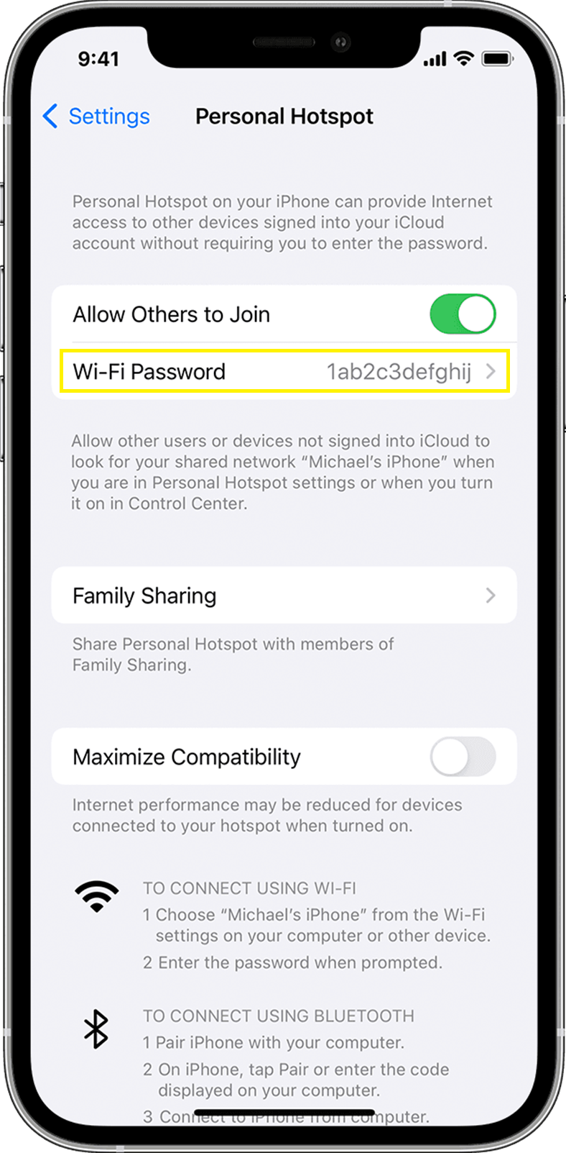

**Android Personal Hotspot Setup**

**How do I turn on Wi-Fi hotspot (data sharing) on Android devices?**

To turn on Wi-Fi hotspot on your Android smartphone or Android device as a hotspot, see instructions corresponding to the brand of your device:  
  
**Samsung**  
Navigate to Connections > Mobile hotspot and tethering > Mobile Hotspot and toggle it on. A pop-up window will appear, where you can find the Wi-Fi password for devices that want to connect.  
  
**Motorola**  
Navigate to Settings > Network & internet > Hotspot & tethering. Here, you can select to share a connection via Wi-Fi, USB, or Bluetooth.  
  
For a Wi-Fi connection, tap Wi-Fi hotspot and toggle it on. The hotspot name will be displayed on this screen. Tap Advanced > Hotspot password for the password.  
  
**Google Pixel**  
Pull down from the top of the screen and navigate to Settings > Network & Internet > Hotspot & tethering > Wi-Fi Hotspot, and toggle the switch to on. The hotspot name and password will then be visible.  
  
**Huawei**  
Navigate to Settings > Wireless & networks >Tethering & portable hotspot > Portable Wi-Fi hotspot. Choose Configure Wi-Fi hotspot to set a name, security setting, and password for your hotspot, then tap Save.  
  
From your Android Smartphone’s Quick Settings  
Swipe down from the top of the screen to view notifications. Swipe down again to see quick settings. Tap Mobile hotspot to enable.  
If the Hotspot shortcut isn’t already there, tap Edit, then long-press on Hotspot and drag it to the grid of tiles.